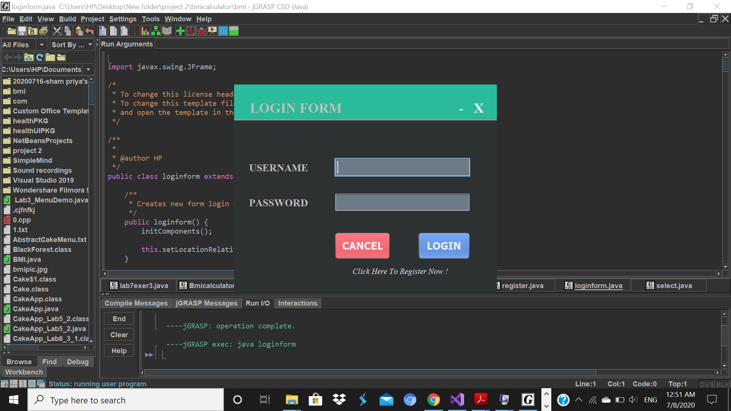1.THIS IS THE FIRST FORM OF BMI CALCULATOR.BEFORE LOGIN ,WE SHOULD REGISTER .

2.THEN REGISTER THE BMI REGISTER FORM AND CLICK REGISTER BUTTON TO LOGIN.

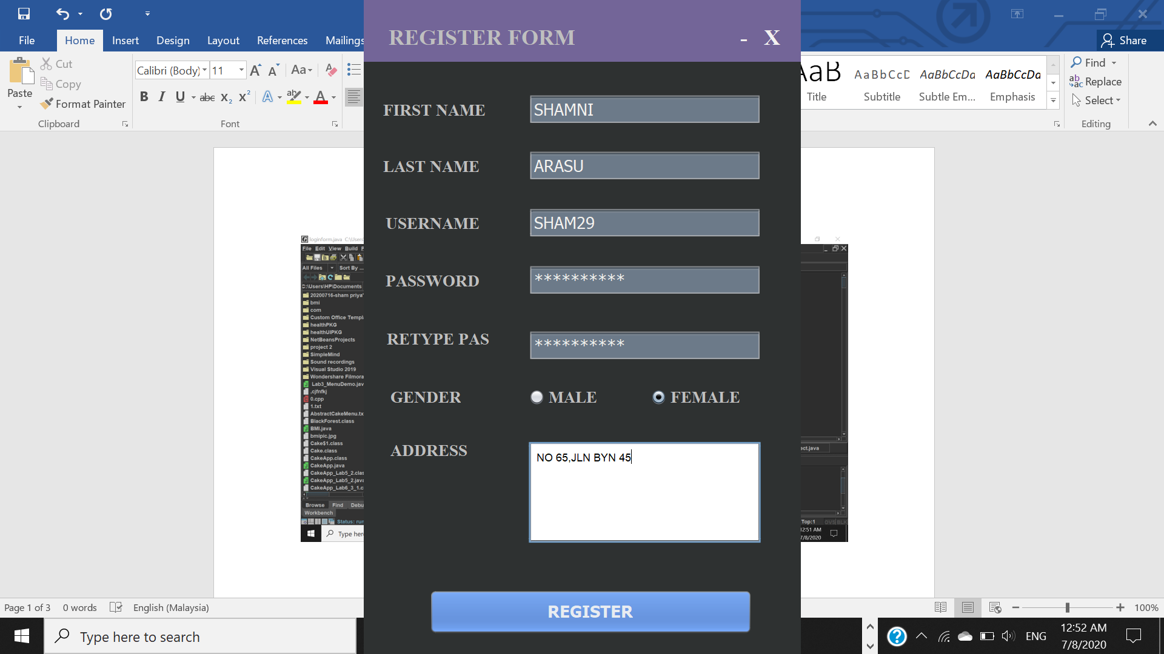

3.FILL UP THE LOGIN FORM AND CLICK LOGIN TO NEXT PAGE.

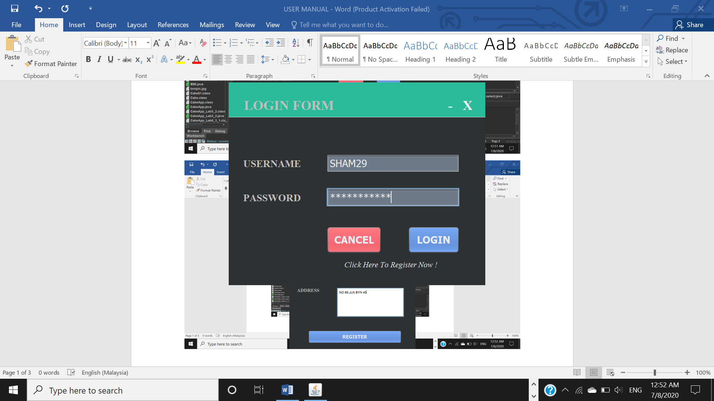

4.AFTER THAT,WE ENTER TO SELECT FORM WHICH CONTENT 3 ELEMENT(ABOUT,FORMULA AND CHECKER)

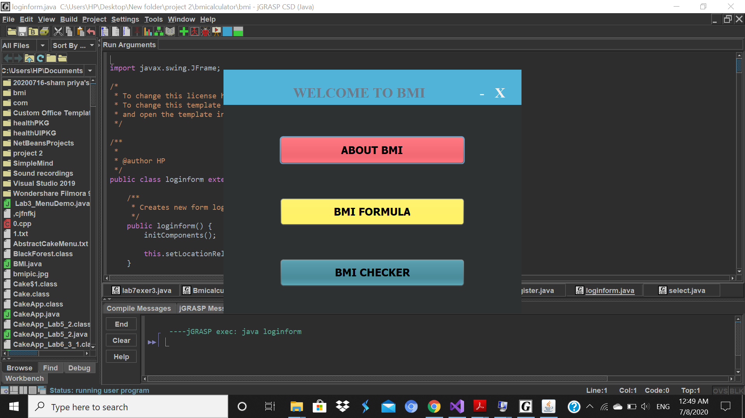

5.THIS IS ABOUT BMI. IF YOU NEED TO GO BACK TO SELECT FORM,CLICK BACK.

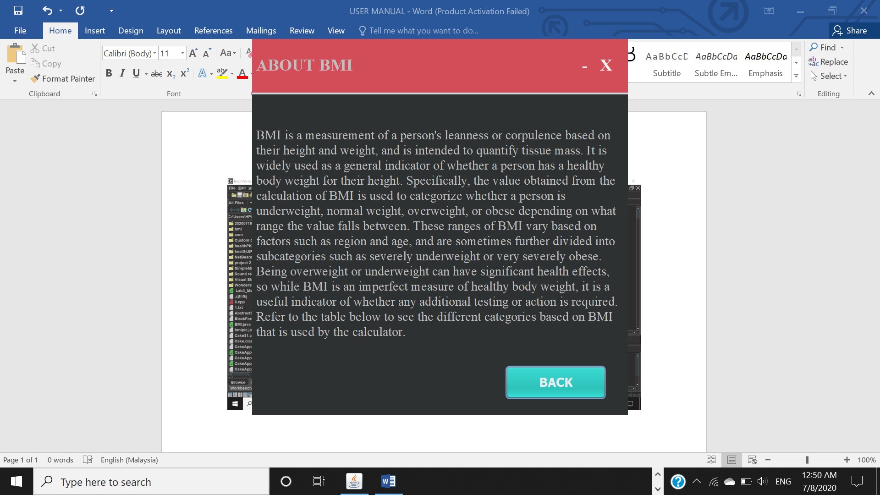

6.THIS IS BMI FORMULA.

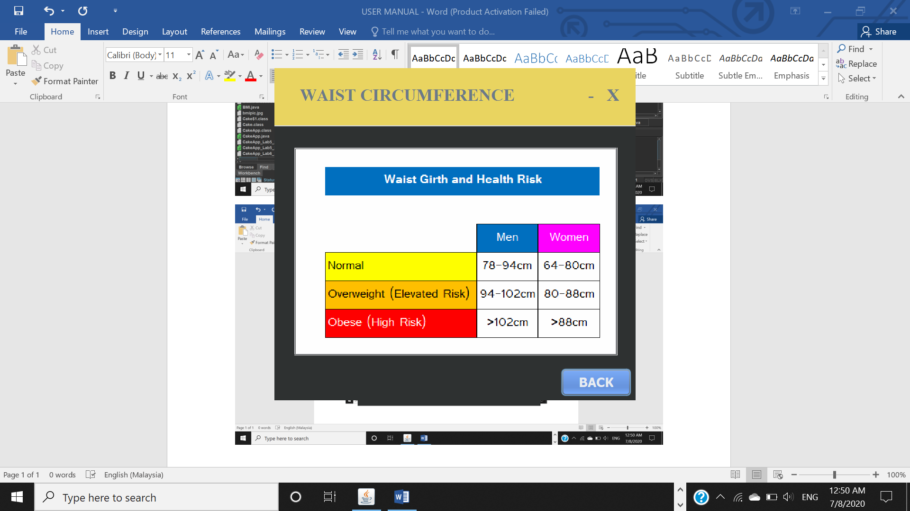

7.IF YOU PRESS THE BMI CHECKER, YOU CAN ENTER THIS BODY MASS INDEX.

